**CHAPTER 1**

**THE PROJECT OVERVIEW**

**Introduction and Rationale**

In the present age, PCs develop quick and turned into a lifestyle in working. It is obvious that these days, we know how to utilize PC. A large portion of the workplaces currently utilize PCs to associate different workplaces by use of internet especially to those partnered organizations like the Philippine Red Cross.

Nowadays, people struggle to find blood for their patients commonly during emergencies. Lack of stock, compatibility and distant blood banks are some of the concerns raised. Blood banks cannot accommodate all requests due to the lack of blood donors. Due to this problem, some patients cannot recover from their diseases and result to an even worst situation.

Considering all these concerns, this research was conducted to solve such problems with the help of information technology in designing a web-based blood banking system that will help people find blood faster and easier. This system will be implemented through website that can be accessible anytime and anywhere as long as there is internet connection. This system is very significant because it will lead us to faster transaction and guarantee us faster blood seeking. With the help of this system, problems existing will be lessened, and because of this it will be easy now to find blood.

Thus, the proponents want to propose this research at the three Red Cross blood banks in Misamis Occidental including Ozamiz, Oroquieta and Tangub City chapter.

**Significance of the Study**

The Project Blood Seeker (*Web Based Blood Banking System*) can be a big contribution in the field of Information Technology. Through this innovative project specifically in the field of web development, this project could greatly contribute people who will use this kind of innovation. This will give a faster and reliable system that can be accessible anytime there is an urgent need. This project will benefit the people who will be improving the methods for their future research endeavor. It will be a big impact to the society that Information Technology is very useful nowadays in terms of blood banking. Aside from it, the project will be beneficial for the following:

**People:** This project will help people work for their needed blood with comfort and ease despite; they could save money and effort.

**Administrators:** This project will help blood bank administrators lessen their paper works and make the operation faster and convenient.

**Blood Donors:** This project will help blood donors lessen the hassle of finding multiple forms in requesting or even seeking for blood availability.

**Future Researchers:** This project will also be useful for researchers as an avenue to improve the system used in this study.

**Methodology**

**Environment**

The research study was conducted at the Philippine Red Cross Misamis Occidental Offices which includes Oroquieta, Ozamiz, and Tangub City Chapters. Red Cross Oroquieta Chapter is located at Capitol Compound Oroquieta City; Red Cross Ozamiz Chapter is located at S.M Lao Hospital Compound at Barangay Manabay Ozamiz City and Red Cross Tangub Chapter is located at PRC City Hall Drive Tangub City. Their services include national blood services, disaster management services, safety services, health services and social services.

**Respondents**

The respondents of the study are the personnel who conducted blood donation drives of Red Cross Oroquieta, Ozamiz and Tangub Chapter, and the assigned administrator of the Blood Banking Program of the Philippine Red Cross of the three chapters are involved. Each of the blood banks has one (1) or two (2) administrators so there will be six (6) admin that will be interviewed because they will be the one who will handle the system. Then, there will be 70 respondents classified as users and donors and surveyed for their response to the questionnaires provided because they will also use the website. The proponents choose random respondents who have experience in blood donation and also those who are looking for blood transfusion.

**Instruments**

**Data Gathering Tools**

The proponents conducted an interview with the respondents of this study as stated above. Open-ended questionnaire was administered by the proponents to every respondent in the proposed research. By the help of these questionnaires, the researchers were able to absorb and understand the research more and formulate some applicable ideas which are important to the project and collect such important data and information that will guide the proponents accordingly on how this project should be done. The questionnaire consists of 10 Yes or No questions regarding on the experience of users with their struggles in looking for blood and also their insight on the tendency to have a new and improve system in searching for blood. Interview is consisted of 6 open-ended questions and supporting questions that focus or the problems, process, things, reliability, which will be considered as their insight on the possibility of having a new system. Questionnaires and Interview schedule and guide can be seen in appendices.

**Testing Tools**

For testing the web application, the proponents use Selenium a software-testing framework for web applications. It create a quick bug scripts that would help the proponents easily to trace the bug, it also provides a test domain specific language to write tests in a number of popular programming languages, including C#, Python, PHP, etc. Selenium deploys on Windows, linux, and macOS platform and also it is a open-source software.

**Operational Definition of Terms**

**Architectural Design** is a detail design which defines the hardware and software and also the interface that will be used in a system.

**Blood Banking** is a process which collects, separates and stores the blood. It collects a blood of the donor and processes the blood components before the blood transfusion.

**Database** it is a software which all data come from and stored in the database.

**Data Structure** it describes the data of the system and the process of using it.

**Deployment** is to bring a working software to the client.

**Diagram** is showing a structure and it represents the appearance of a certain object.

**Maintenance** is a person assigned to maintain the system.

**PRC (Philippine Red Cross)** is a member of the International Red Cross and Red Crescent Movement.

**Process** is describing the flow of the software example for that is the Waterfall Paradigm.

**SDD (Software Design Description)** it is a documentation of a system which gives an overall guide to the project

**Software** is an installed program that used in a computer.

**SRS (System Requirements Specification)** is a documentthat includes the requirements of the system and what it uses.

**System Architecture** is to describe the structure of the system which represents the flow of the system and what are the software that will be used.

**System Design** is the overall model or plan to be followed both logical and graphical design that is used in development process.

**System Reference** it is a documentation design for the maintenance. It includes the SRS, SDD, etc. that gives information about the current state of the project.

**System Requirements** is the overall requirements of a system that is used as a guide.

**Test Design** is to test the system if it will work and satisfied the user and also to know the problem/issues during the testing.

**Test Plan** is a documentation plan that gives a detailed process of a system.

**UI (User Interface)** is an output interface that interact by a user/client which uses an input device and system software.

**UML (Unified Modeling Language)** is a modeling language to visualize the flow of the system.

**Use Case Diagram** is a behavioral diagram that describe the actions of a system and also the actor.

**User Interface Design** is a UI which represents the simplest design but effective and user friendly.

**User Manual** is a guide for the user/client, which gives an assistance on how to use the system.

**CHAPTER 2**

**THE PROJECT ANALYSIS AND DESIGN**

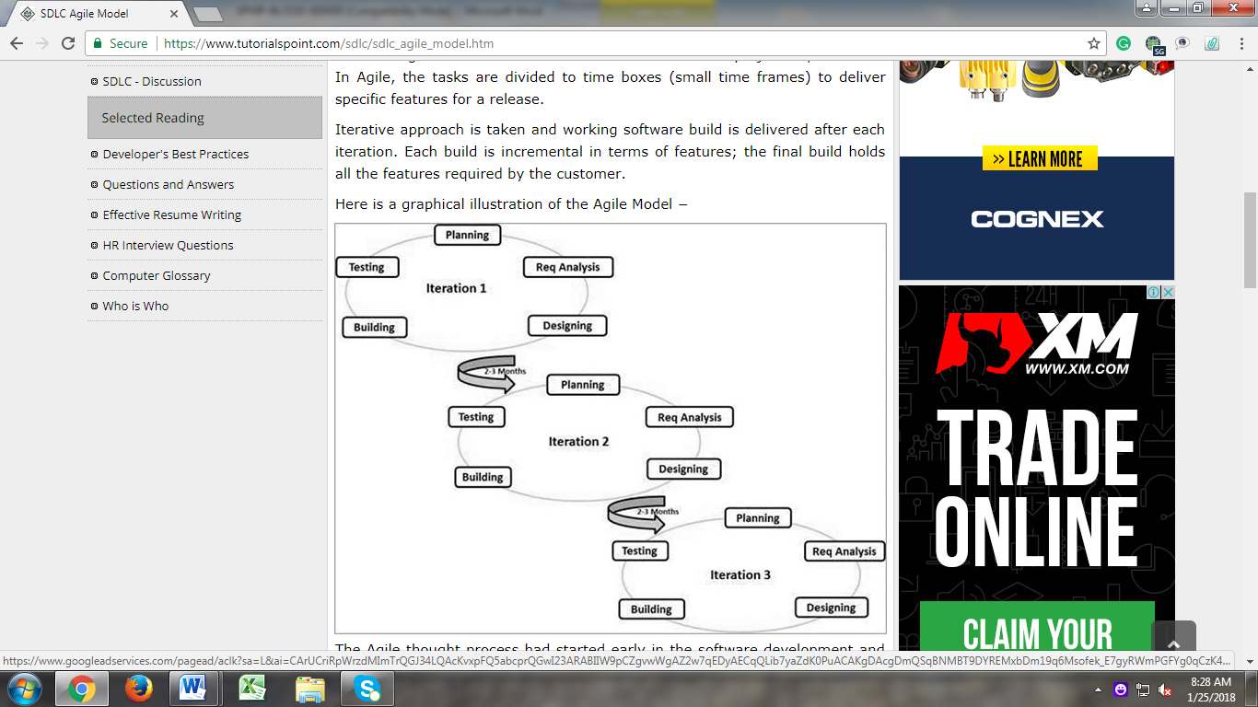**Software Paradigm Used**

Figure 2.0 Agile Model

The project will use agile model for the development process this will allow an incremental development for its deliverable. The development will be done in several and phases and levels. Each phase will present a complete development of the system, with certain functions of the system in every end of the system. The phased approach to the delivery of the system provides flexibility the team that will deliver and gives opportunities to reassess the effort of each of the members and allows both the team and the client to change the content of each phase.

**Planning**

It focused on answering the questions, what needs to be built, when it needs to be completed, how much will it cost, and who needs to be involved, as project manager, we also want to know any dependencies between activities so we can minimize idle time and optimize the schedule. In this process the researcher plan on how to gather data on a certain iteration. Each of the member share ideas on how to conduct or gather the data needed in the system.

**Requirements Analysis**

All possible requirements of the system to be developed are define in this phase documented in a requirement specification document. After the data has been gathered the researcher will analyze the data that is been gathered to developed and captured certain functions or deliverables on the system.

**Design**

The requirement specifications from second phase are studied in this phase and system design is prepared. System design helps in specifying hardware and system requirements and also helps in defining overall system architecture. After the deliverables has been gathered the researcher will make designs on how the system will interact with the user and the hardware. The researcher may also give design architecture that will help in the interaction of the hardware, user and the system.

**Coding**

With inputs from system design, the system is first developed in small programs called units, which are integrated in the next phase. Each unit is developed and tested for its functionality which referred to as Unit Testing. In this phase the researcher has transform all the system design to programming codes that gives the hardware instructions on how the system works on the certain functions.

**Unit Testing**

All the units developed in the implementation phase are integrated into a system after testing each unit. Post integration the entire system is tested for any faults and failures. In this phase the user, client, and researcher will test all the functions and modules that compose the system. This is to identify what are other functions that is lacking and it will also give the researcher find bugs.

**Acceptance Testing**

The process that obtains confirmation that system meets mutually agreed-upon requirements. In this phase the researcher and the client will agree on what are the findings unit testing and will be agreed and accepted by the client and the researchers.

**Load Testing**

Is the process of putting simulated demand on software, an application or website in a way that tests or demonstrates its behavior under various conditions.

**Functionality Testing**

Is a [quality assurance](https://en.wikipedia.org/wiki/Quality_assurance) process and a type of [black-box testing](https://en.wikipedia.org/wiki/Black-box_testing) that bases its test cases on the specifications of the software component under test.

**Interface Testing**

Is the testing done on AUT which actually verifies whether the communication between two different software systems are done correctly.

**Compatibility Testing**

Is a non-functional testing conducted on the application to evaluate the application's compatibility within different environments.

### **Navigation Testing**

Navigation tests analyze how users navigate through website or application. The results will help to the proponents to improve information architecture. Navigation testing is important it presents an actual user interface to the user, which may include things like working menu bars, visually designed controls, and so on. In this case, the proponents test any kind of browser to test the UI if there are changes on any browsers, the following browsers are Google Chrome, Microsoft Edge, Mozilla Firefox and Internet Explorer.

**Test 2:**

Table 4.1 Admin Invalid Login

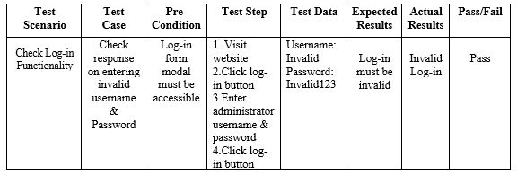

**Result:**

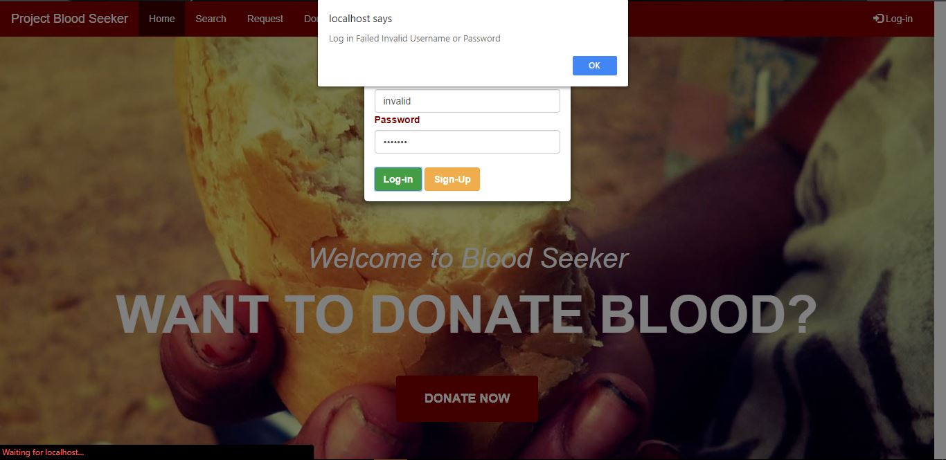

Figure 4.1 Invalid Admin Log-in

**Test 3:**

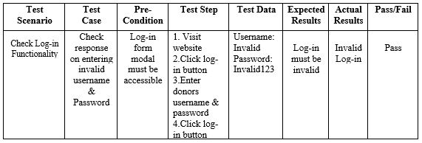Table 4.3 Donor Invalid Login

**Result:**



Figure 4.3 Invalid Donor Log-in